MBR corrupted in CentOS 7 / RHEL 7

Create an issue
Become root
df -h
dd if=/dev/zero of=/dev/sda bs=256 count=1
init 6

MBR corrupted then getting an error as shown in the image below

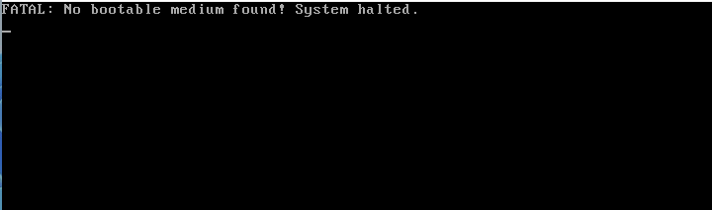

Attach dvd.iso as shown in the image below

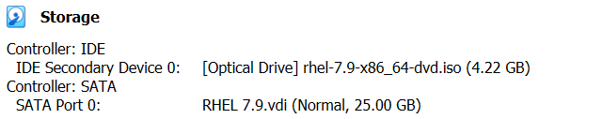

Reset OS through VM
Press Enter on Troubleshooting mode

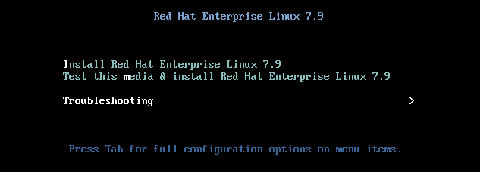

Press Enter on Rescue a Red Hat Enterprise Linux system (Rescue mode)

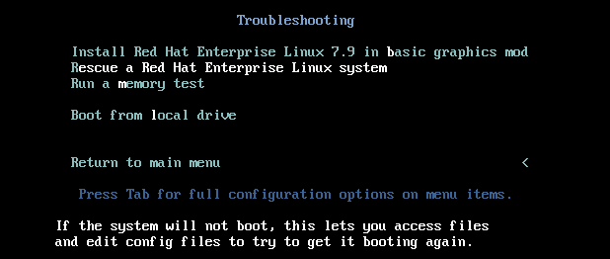

1) Continue 1 Enter

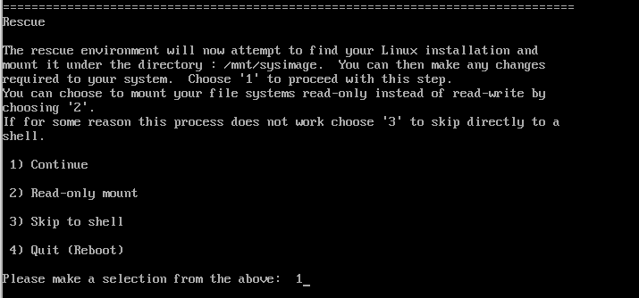

Enter

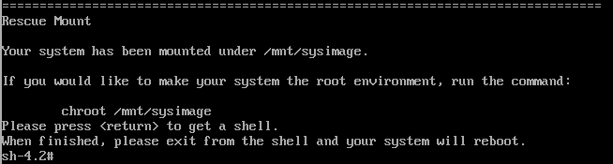

df -h

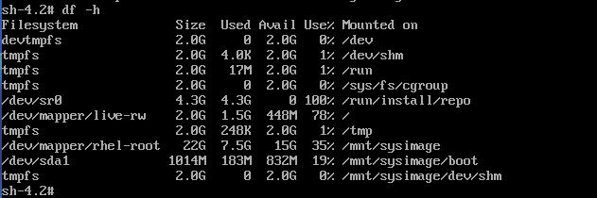

chroot /mnt/sysimage

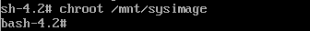

df -h

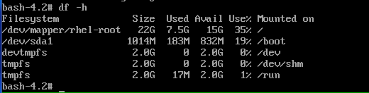

grub2-install /dev/sda

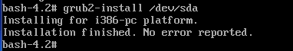

exit

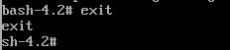

Remove dvd.iso as shown in the image below

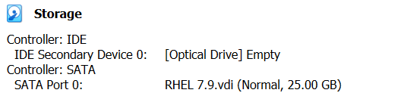

Reset OS through VM
The system is started booting up without any issue

